**NAME: NISHA K**

**REG: NO: 192411231**

**EXP: NO: 4**

Create a simple cloud software application for Car Booking Reservation System using any Cloud Service Provider to demonstrate SaaS.

**AIM:**

To design and deploy a simple **cloud-based Car Booking Reservation System** using Zoho Creator and demonstrate the concept of **Software as a Service (SaaS)**.

**PROCEDURE:**

1. Log in to **Zoho.com** and access the **Zoho Creator** platform.
2. Create a **new application** and provide a suitable name (e.g., *Car Booking Reservation System*).
3. Design the application by adding necessary **forms** (Car details, Customer registration, Booking form) and **reports** for reservation management.
4. Configure and **deploy the application** on the Zoho cloud platform.
5. Share the application link with users, enabling them to book cars directly via the internet.

**OUTPUT:**

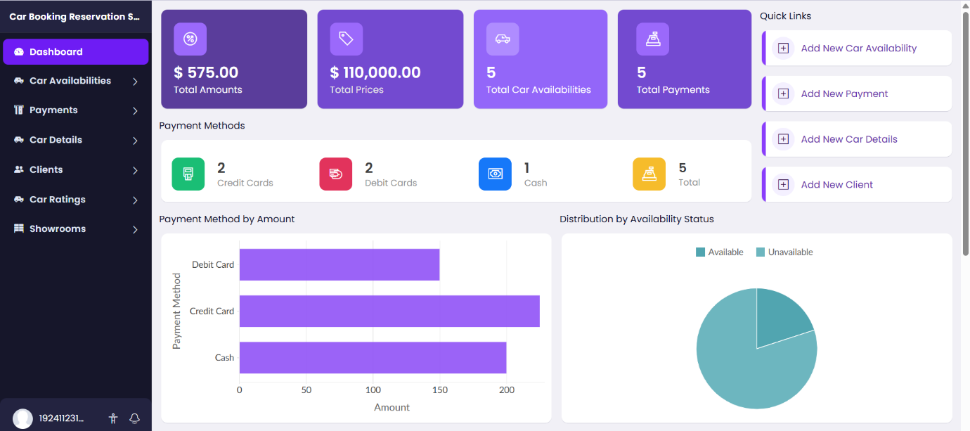

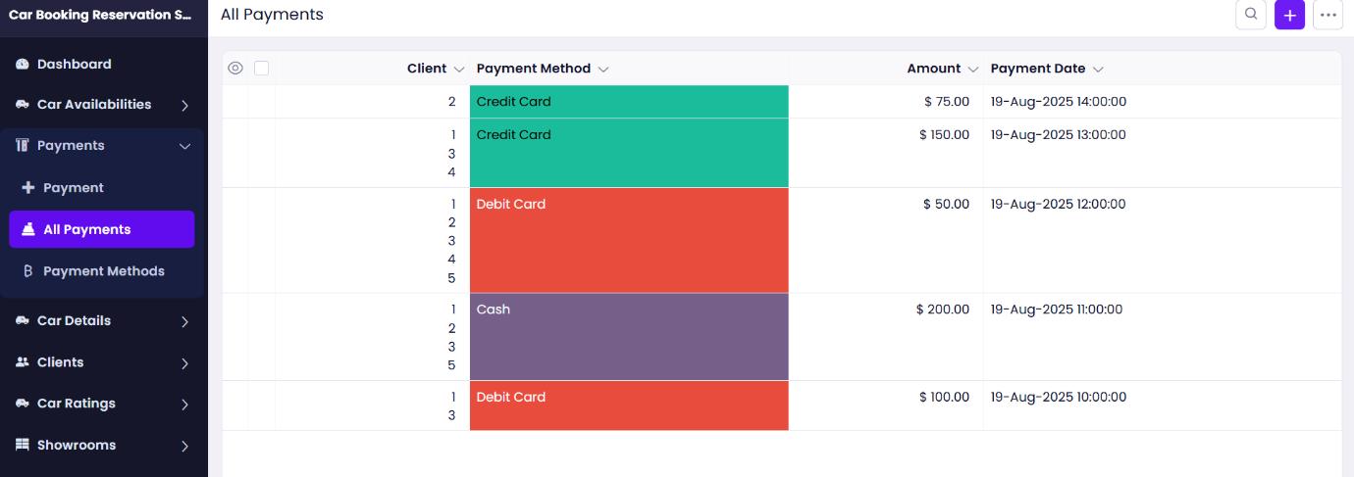

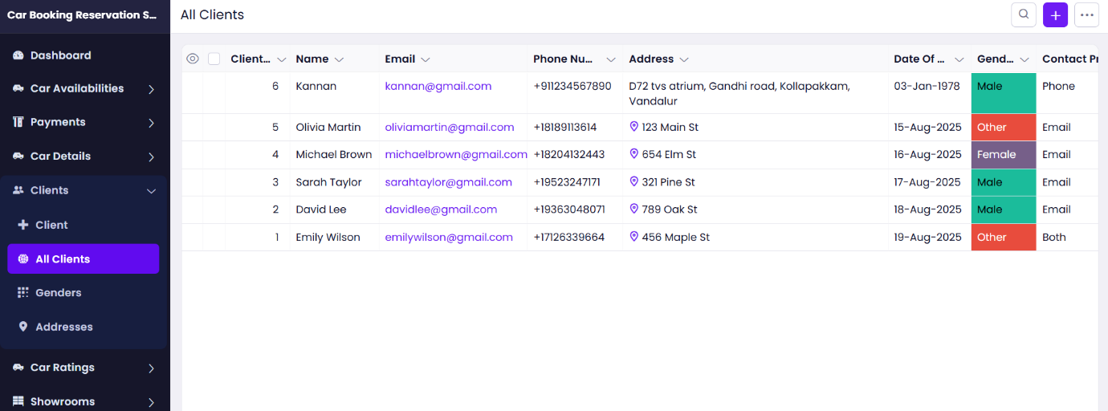

**RESULT:**

A Car Booking Reservation System was successfully created and deployed using Zoho Creator. Users can register, view available cars, and make bookings online through the cloud, thereby demonstrating the SaaS model.